Data Science
A project report submitted for
Information technology
By
Nikita Mehra
Under the guidance of
Praveen Kumar Joshi Sir

Ever green sr. sec. school
(Governed by educational welfare society)
Tularampur -223139, District -Nainital
Uttarakhand ,India
October -2021

Certificate
This is certify that the project entitled "Data Science" being submitted to Ever Green Sr. Sec. School , Haldwani for the project work of Information technology is a record of work carried by MR Praveen Kumar Joshi under my guidance and supervision.

Date:4/Oct/21

Supervisor
Mr PraveenJoshi
TGT Computer
EG Haldwani

Abstract
Data Science encompasses a set of principles, problems definition, algorithms, and processes for extracting non obvious and useful patter from large data set .Many of elements of data science have bees developed in related field such as machine learning and data mining.

Acknowledgments
I would like to express my most sincere heartfelt gratitude and respect to my Supervisor Mr PraveenJoshi ,for suggesting the topic for my project workand for his excellent guidance, valuable suggestions and endless support throughout the course of my preparing the report I am greatly indebted for his construction suggestions and criticism from time to time during the progress of my work .
I would like to express my gratitude and sincere thanks to MR Parwal principal of school,and entire faculty who has imparted considerable knowledge to me .
I'm also thankful to my all friends and staff members of the department of computer science and engineering and to my well wishers for their inspiration and help
Finally I express my deepest gratitude to my parents for their continuous encouragements, understanding and support.

Nikita Mehra

Table of contents

Chapter | Topic | Page no.
 | Certificate
 | Acknowledgments
 | Abstract
1. | Introduction
2. | What is Data Science?
3. | Who oversees the data science process?
4. | What’s the difference between data science, artificial intelligence, and machine learning?
5. | What is data scientist?

Introduction
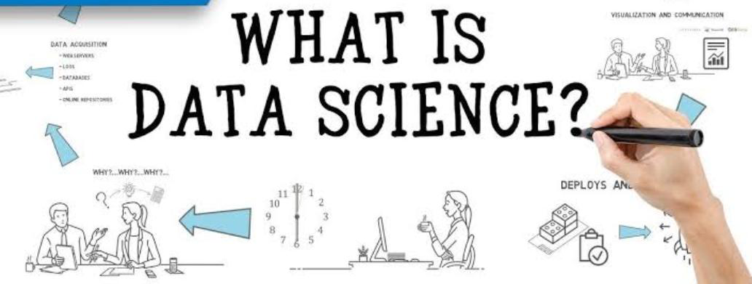
What is Data Science?
Data Science means we have taken a marketing strategy by analyzing the data .The same things that we have taken large data and analyze it and then we take a decision .So this is data Science.

Data science continues to evolve as one of the most promising and in-demand career paths for skilled professionals. Today, successful data professionals understand that they must advance past the traditional skills of analyzing large amounts of data, data mining, and programming skills. In order to uncover useful intelligence for their organizations, data scientists must master the full spectrum of the data science life cycle and possess a level of flexibility and understanding to maximize returns at each phase of the process.

Data science encompasses preparing data for analysis, including cleansing, aggregating, and manipulating the data to perform advanced data analysis. Analytic applications and data scientists can then review the results to uncover patterns and enable business leaders to draw informed insights.
Data science: An untapped resource for machine learning
Data science is one of the most exciting fields out there today. But why is it so important?

Because companies are sitting on a treasure trove of data. As modern technology has enabled the creation and storage of increasing amounts of information, data volumes have exploded. It’s estimated that 90 percent of the data in the world was created in the last two years. For example, Facebook users upload 10 million photos every hour.

But this data is often just sitting in databases and data lakes, mostly untouched.

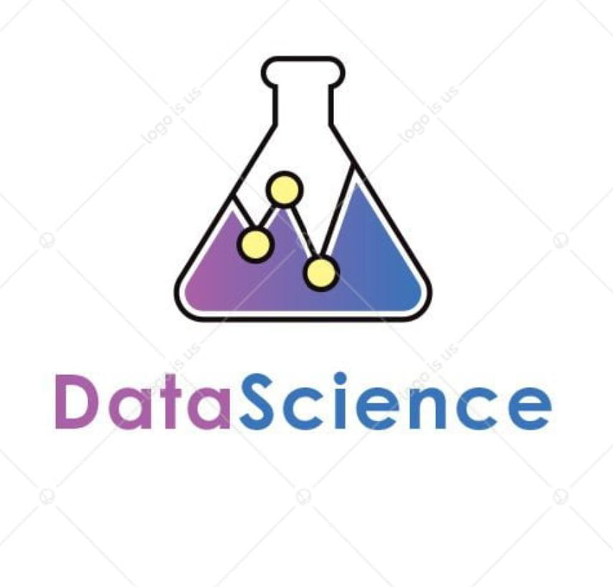
The wealth of data being collected and stored by these technologies can bring transformative benefits to organizations and societies around the world—but only if we can interpret it. That’s where data science comes in.

Data science reveals trends and produces insights that businesses can use to make better decisions and create more innovative products and services. Perhaps most importantly, it enables machine learning (ML) models to learn from the vast amounts of data being fed to them, rather than mainly relying upon business analysts to see what they can discover from the data.

Data is the bedrock of innovation, but its value comes from the information data scientists can glean from it, and then act upon.


Who oversees the Data Science Process?
At most organizations, data science projects are typically overseen by three types of managers:

Business managers: These managers work with the data science team to define the problem and develop a strategy for analysis. They may be the head of a line of business, such as marketing, finance, or sales, and have a data science team reporting to them. They work closely with the data science and IT managers to ensure that projects are delivered.

IT managers: Senior IT managers are responsible for the infrastructure and architecture that will support data science operations. They are continually monitoring operations and resource usage to ensure that data science teams operate efficiently and securely. They may also be responsible for building and updating IT environments for data science teams.

Data Science Managers: These managers oversee the data science team and their day-to-day work. They are team builders who can balance team development with project planning and monitoring.

But the most important player in this process is the data scientist.
What’s the difference between Data Science, Artificial Intelligence, and Machine learning?
To better understand data science—and how you can harness it—it’s equally important to know other terms related to the field, such as artificial intelligence (AI) and machine learning. Often, you’ll find that these terms are used interchangeably, but there are nuances.

Here’s a simple breakdown:

AI means getting a computer to mimic human behavior in some way.
Data science is a subset of AI, and it refers more to the overlapping areas of statistics, scientific methods, and data analysis—all of which are used to extract meaning and insights from data..
Machine learning is another subset of AI, and it consists of the techniques that enable computers to figure things out from the data and deliver AI applications.
And for good measure, we’ll throw in another definition.
Deep learning which is a subset of machine learning that enables computers to solve more complex problems.

What is a Data scientist?
As a specialty, data science is young. It grew out of the fields of statistical analysis and data mining. The Data Science Journal debuted in 2002, published by the International Council for Science: Committee on Data for Science and Technology. By 2008 the title of data scientist had emerged, and the field quickly took off. There has been a shortage of data scientists ever since, even though more and more colleges and universities have started offering data science degrees.

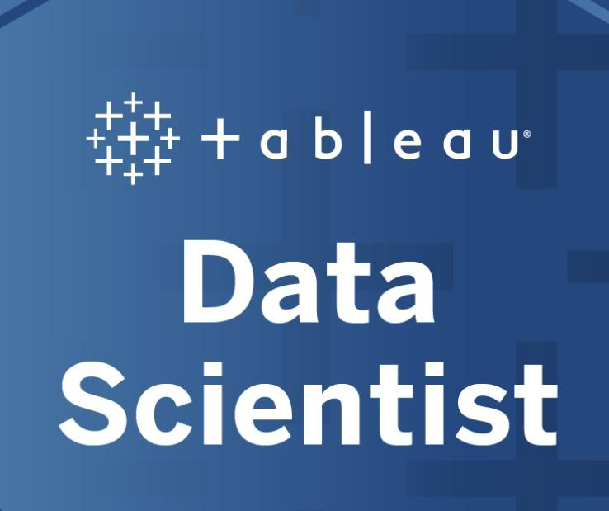
A data scientist’s duties can include developing strategies for analyzing data, preparing data for analysis, exploring, analyzing, and visualizing data, building models with data using programming languages, such as Python and R, and deploying models into applications.

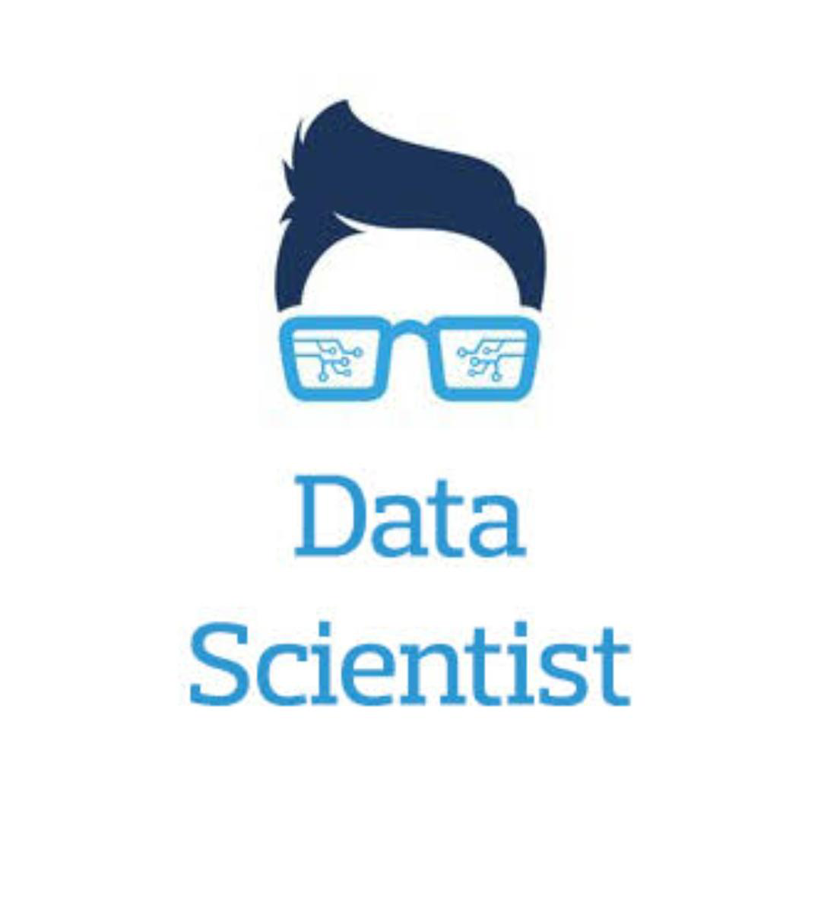
The data scientist doesn’t work solo. In fact, the most effective data science is done in teams. In addition to a data scientist, this team might include a business analyst who defines the problem, a data engineer who prepares the data and how it is accessed, an IT architect who oversees the underlying processes and infrastructure, and an application developer who deploys the models or outputs of the analysis into applications and products.




